

THE HERITAGE

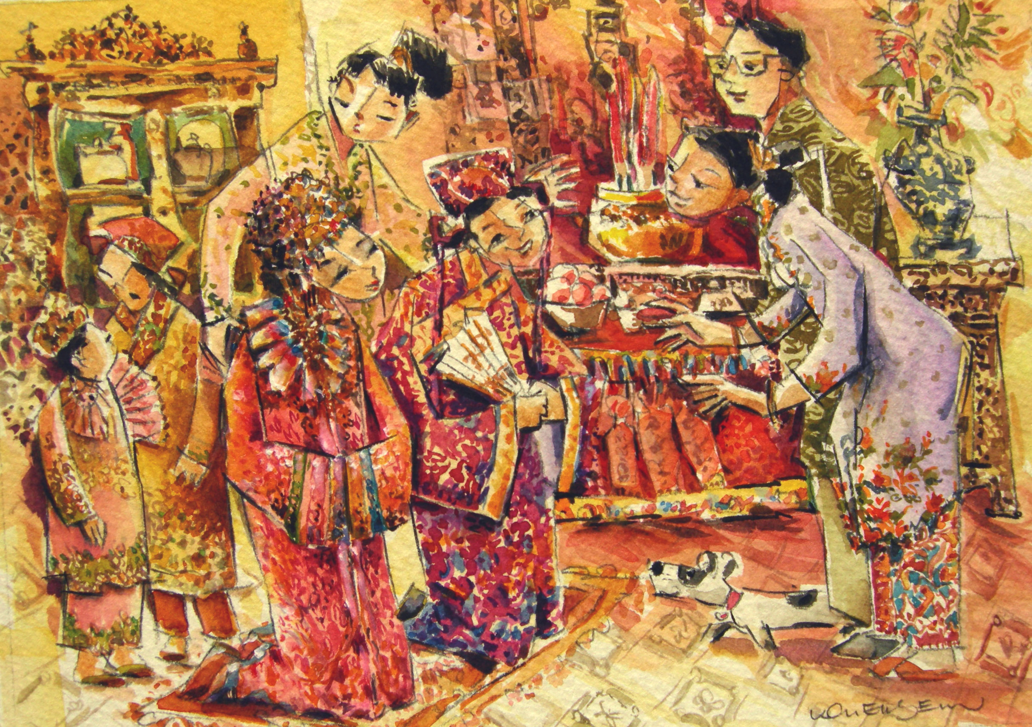
Peranakan Wedding Tea Ceremony

The wedding couple kneels before the Bride’s parents as a sign of respect

